**Assignment-6:**

**- Find the inventory by :-**

**- Category**

**- Sub Category**

**- Product**

- **Location**

**- Create a Dashboard**

**- Create a story showing the visuals from Location, Product & Category**

Under Connect section, click on "Text file" and browse through to connect to "Supply Chain Master" csv file.

**Find the inventory by Category:**

step 1) Hold ctrl and select "Category" dimension and "On Hand" measure then select pie chart visual from Show Me section.

step 2) Drag and drop "Category" dimension and "On Hand" measure on to Label under Marks card.

we can see the visual as shown below:

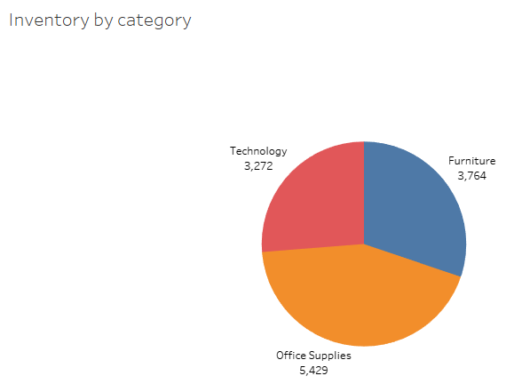

**Find the inventory by Sub Category:**

step 1) Hold ctrl and select "Sub-Category" dimension and "On Hand" measure then select tree map visual from Show Me section.

step 2) Drag and drop "On Hand" measure on to Label under Marks card.

we can see the visual as shown below:

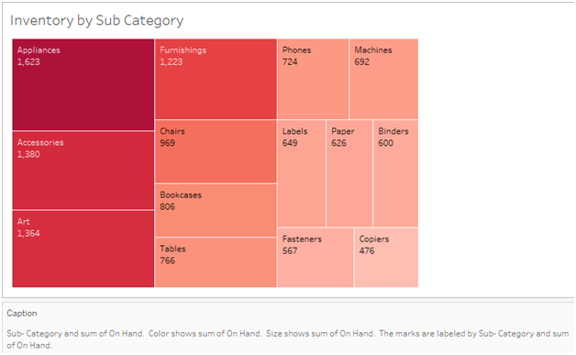

**Find the inventory by Product:**

step 1) Hold ctrl and select "Product Name" dimension and "Onhand" measure then select horizontal bar chart visual from Show Me section.

step 2) Click on 'T' icon to show the labels.

step 3) Drag and drop "Onhand" measure on to Color under Marks card.

step 4) Click on the downward arrow of Onhand Color Legend and click on "Edit Colors".

In the pop up window, select Palette type as "Red-Green-Gold Diverging" or anything of your choice and click on OK.

we can see the visual as shown below:

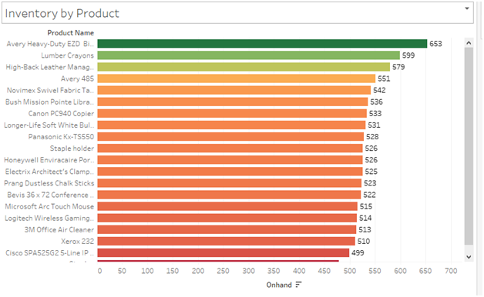

**Find the inventory by Location:**

step 1) Right click on the "Location" dimension and click on "Geographical Role" and select "State/Province" from the options.

step 2) Right click on the "Location" dimension and click on "Add to Sheet".

step 3) Right click anywhere on the map visual and click on "Edit Locations".

step 4) Change "Country/Region" type to United States.

step 5) Drag and drop "Location" dimension on to Color under Marks card.

step 6) Drag and drop "Onhand" measure on to Label under Marks card.

if some of the dots do not show labels, this is because of overlapping. in such case:

Click on the Label box under Marks card and tick mark "Allow labels to overlap other marks" checkbox.

we can see the visual as shown below:

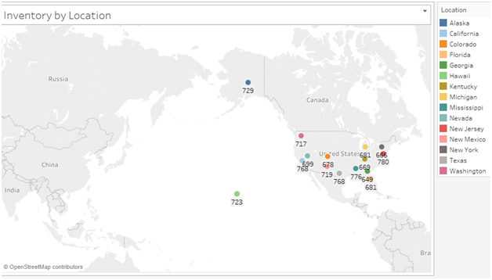

**Dashboard:**

step 1) Click on "Dashboard" on the top section and click on "New Dashboard".

Then a blank dashboard page appears. Rename it of your choice.

step 2) On the left side, Choose the "Size" type as "Automatic".

step 3) Drag and drop or double click on each visual under "Sheets".

step 4) Click on "Dashboard" on the top section and click on "Show Title".

Give the relevant title name.

Right click on the title and Format its font type, size and alignment.

Then the basic dashboard of the visual segments look like below:

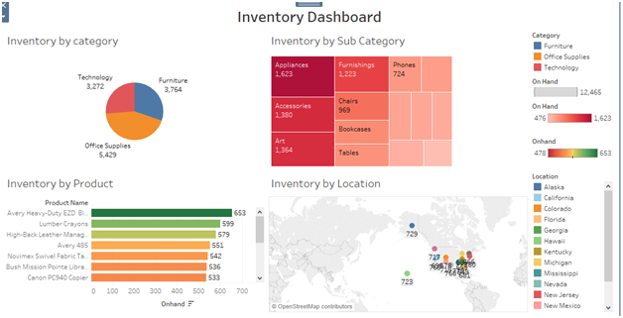

**Story:**

step 1) Click on "Story" on the top section and click on "New Story".

Rename the Story sheet with a relevant name.

step 2) Double click on "Inventory by Location" under left side Story section.

A new caption box gets loaded along with the visual.

Rename the caption box as "Inventory by Location"

step 3) Double click on "Inventory by Product" under left side Story section.

A new caption box gets loaded along with the visual.

Rename the caption box as "Inventory by Product"

step 2) Double click on "Inventory by Category" under left side Story section.

A new caption box gets loaded along with the visual.

Rename the caption box as "Inventory by Category"

Now, we can see Story Sheet as shown below:

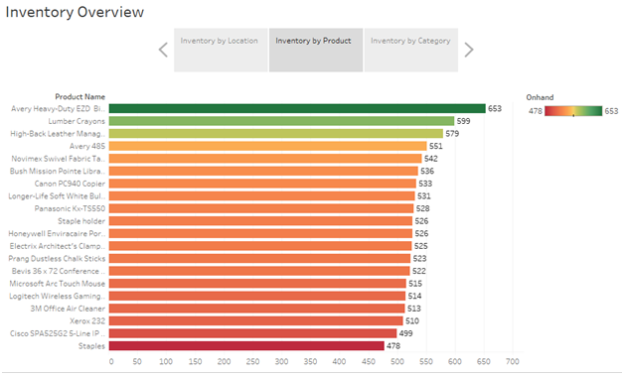

[Click on this link to view Assignment-6 workbook on my tableau public profile](https://public.tableau.com/app/profile/snehal7939/viz/Assi_6/InventoryOverview)